Ashbar Hussain

25K0028, BAI-1A

Question 1



Question 2

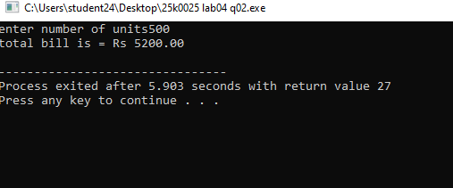

Questuon 3)

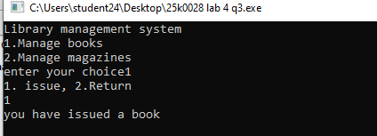

Question 4)

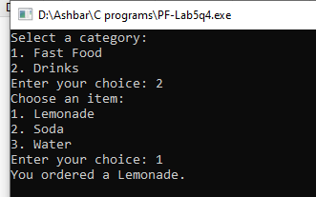

Question 5)

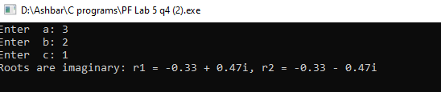

Question 6)

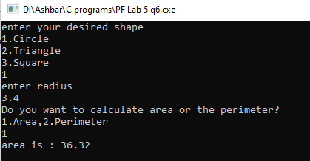

Question 7)

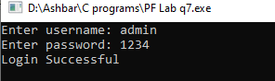

Question 8)

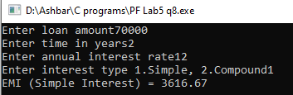

Question 9)

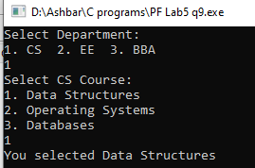

Question 10)

